Harman Contribution log
Today I did the Testing part of the game as my group leader assign me the task also, I make a video
This video will reach to the user when the user pass the quiz
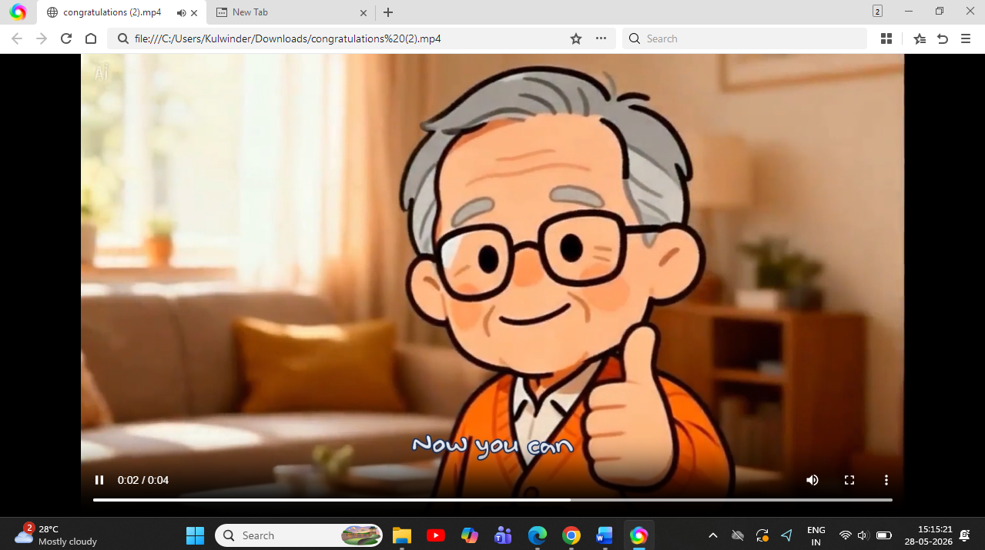
This video will reach to the user if the user fails to pass the Quiz
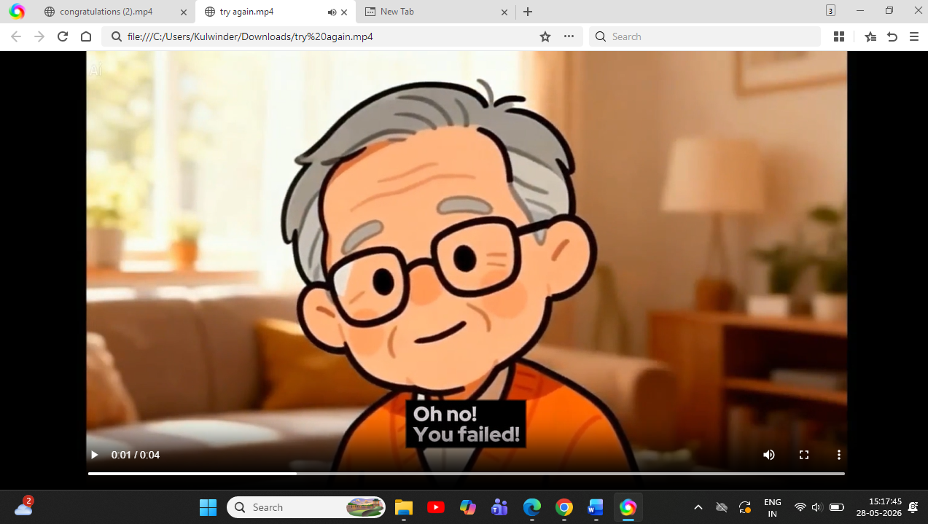

Below is the form which I fill today while testing the prototype
7. Task C: Testing and bug fixing
What testing means this week
Testing means checking whether the game/prototype works, whether users can understand it, whether feedback is clear, and whether the cyber-safety lesson is delivered. You do not test only by saying “it works”. You must record what was tested, what failed, what was fixed, and what still needs improvement.
Test area | What to test | Evidence required
Start/opening test | Does the game open/start correctly? | 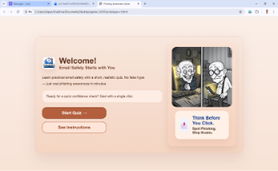Yes, the game open/start correctly
Navigation/flow test | Can the user move through the intended journey? | 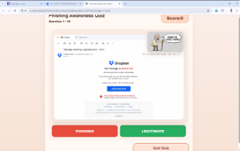Yes, we can move through the intended journey
Interaction test | Do buttons, choices, sprites, links, or answers work? | 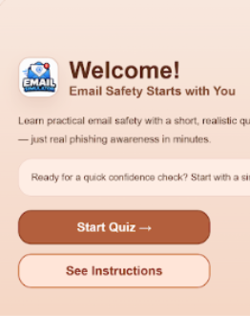  Yes, the buttons work instantly as you click the start button it will take you to the quiz directly
Feedback test | Does the game explain correct/wrong answers clearly? | 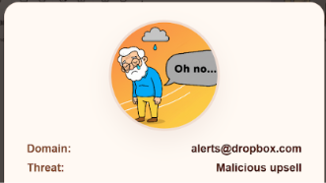Yes, after the completion of the question it will show you that the question is correct or wrong and also why it is wrong.
Learning test | Can the tester identify the cyber-safety lesson? | 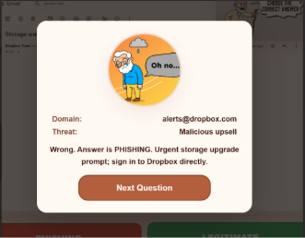As shown in the figure the user will get to know about the lesson regarding the cyber security in the feedback section
Accessibility test | Is text readable, buttons visible, instructions clear, and design suitable for the target audience? | Yes, everything in the game is clearly visible and also it is suitable for the target audience (55 over) as the colors we used in the game are not too bright and we use simple language, less text and also we add animated videos for the instruction part so that the user get better understanding through the voice and signs instead of reading and understand.
Bug test | What does not work yet? | GitHub link of file bug fix log: https://github.com/BipanSajwal/503IT-Group-Game-/blob/main/week-4-final-game-completion/bug%20fix%20log.docx
7.1 Platform-specific testing instructions
Platform | How to test | Evidence to upload
Scratch | Click the green flag. Test each screen/sprite/choice. Test correct and wrong answers. Check score/reward if used. Ask another group to play it without explanation. | Scratch link, start/challenge/feedback screenshots, testing-record.md
HTML in browser | Open the file or local project in Chrome/Edge/Safari. Click each answer button. Check correct and wrong feedback. Check that the page displays correctly. If using VS Code, run through browser or Live Server. | I Already provide the evidence of the working prototype in the last section please have a look on that
Backend/full-stack | Run the frontend and backend. Check that pages load, data is saved/returned if relevant, and no errors appear. Record setup steps and known limitations. | README instructions, screenshots, testing-record.md, bug-fix-log.md
Canva/PowerPoint/quiz tools | Open the prototype/link. Follow the user journey. Check that users can understand instructions, choices, feedback, and learning outcome. | Export/link, screenshots, peer review notes
7.2 Testing record template
Already Uploaded in Section 7 Task-C  Testing question | Yes/No | Notes / evidence
Does the prototype open or start correctly? | Yes | Already Uploaded in Section 7 Task-C
Is the welcome/title screen clear? | Yes | Already Uploaded in Section 7 Task-C
Are the instructions easy to understand? | Yes | We add Animated video instead of text because it makes the person easy to understand
Can the player understand what to do next? | Yes | As we add the interactive buttons which guides the user that what to do next
Do the choices/buttons/interactions work? | Yes | Screenshots Already Uploaded in Section 7 Task-C
Does the correct answer show correct feedback? | Yes | Already Uploaded in Section 7 Task-C
Does the wrong answer show helpful feedback? | Yes | As it shows the exact reason why it is wrong and also t shows what type of attack the black hat hacker tries on you. Screenshots Already Uploaded in Section 7 Task-C
Does the feedback explain the cyber-safety lesson? | Yes | Already Uploaded in Section 7 Task-C
Is there a reward, score, star, level, or success message? | Yes | It will give the score According to the user knowledge
Is the design suitable for the target audience? | Yes | As I uploaded every screenshot to the GitHub and it shows that the display colors are very light and eye friendly
What needs improvement before submission? | In progress | Before submission we will take the feedback of the tutor and had some group meetings and then we will focus on the limitations of the game

7.3 Bug-fix log template
Bug / issue found | Impact on user | Fix applied | Fixed by | Status
Images or animation was not good in the welcome page. | Users might feel reading more rather than playing a game. | Use videos and images of old aged people. | Harmanpreet, Bipan. Ramesh | Done
A lot of writing was included in the instruction page. | Instructions was more time consuming and complex for our target audience. | Instead of writing, we use video of around 30s that describe instructions of the game. | Harmanpreet | Done
Real email page was not used in the game | Users will not feel like reading real emails which will make the game less engaged. | Use real emails | Bipan | Done
Scoreboard was not visible properly | They will be disappointed for not being able to see their achieved score. | Make it bigger. | Bipan | Done

